UNITED STATES

SECURITIES AND EXCHANGE COMMISSION

Washington, D.C. 20549

SCHEDULE 14A

(Rule 14a-101)

Proxy Statement Pursuant to Section 14(a)

of the Securities Exchange Act of 1934

Filed by the Registrant ☒

Filed by a party other than the Registrant ☐

Check the appropriate box:

- Preliminary Proxy Statement

- Confidential, for Use of the Commission Only (as permitted by Rule 14a-6(e)(2))

- Definitive Proxy Statement

- Definitive Additional Materials

- Soliciting Material under §240.14a-12
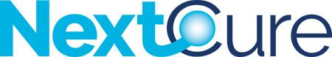

NextCure, Inc.

(Name of Registrant as Specified In Its Charter)

(Name of Person(s) Filing Proxy Statement, if other Than the Registrant)

Payment of Filing Fee (Check the appropriate box):

- No fee required.

- Fee paid previously with preliminary materials.

- Fee computed on table in exhibit required by Item 25(b) per Exchange Act Rules 14a-6(i)(1) and 0-11.



