Filed by NextCure, Inc.
pursuant to Rule 425 under the Securities Act of 1933
and deemed filed pursuant to Rule 14a-12
under the Securities Exchange Act of 1934
Subject Company: NextCure, Inc.
Commission File No.: 001-38905
Date: August 4, 2026

This filing relates to the proposed transaction pursuant to the terms of that certain Agreement and Plan of Merger and Reorganization dated as of July 14, 2026, by and among NextCure, Inc., a Delaware corporation (“NextCure”), Avere Therapeutics, Inc., a Delaware corporation (“Avere”), Neptune Merger Sub Corp., a Delaware corporation and a wholly owned subsidiary of NextCure (“First Merger Sub”), and Neptune Second Merger Sub, LLC, a Delaware limited liability company and a wholly owned subsidiary of NextCure (“Second Merger Sub”), entered into an Agreement and Plan of Merger and Reorganization (the “Merger Agreement”), pursuant to which, among other matters, and subject to the satisfaction or waiver of the conditions set forth in the Merger Agreement, (i) First Merger Sub will merge with and into Avere, with Avere continuing as a wholly owned subsidiary of NextCure and the surviving corporation of the merger (the “First Merger”), and (ii) immediately following the First Merger and as part of the same overall transaction as the First Merger, Avere will merge with and into Second Merger Sub, with Second Merger Sub continuing as the surviving entity and a wholly owned subsidiary of NextCure (the “Second Merger” and, together with the First Merger, the “Merger”).

On August 4, 2026, Avere and NextCure published the following communication:

 | 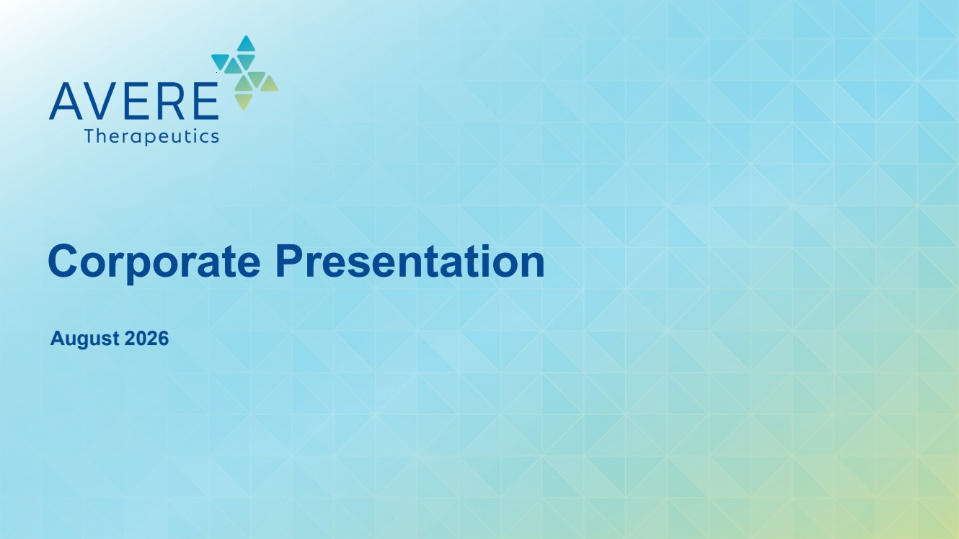 | August 2026 Corporate Presentation
 | 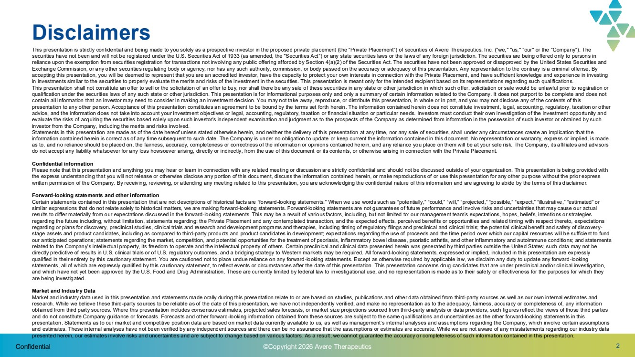 | 2 Disclaimers This presentation is strictly confidential and being made to you solely as a prospective investor in the proposed private placement (the “Private Placement") of securities of Avere Therapeutics, Inc. ("we," "us," "our" or the "Company"). The securities have not been and will not be registered under the U.S. Securities Act of 1933 (as amended, the "Securities Act") or any state securities laws or the laws of any foreign jurisdiction. The securities are being offered only to persons in reliance upon the exemption from securities registration for transactions not involving any public offering afforded by Section 4(a)(2) of the Securities Act. The securities have not been approved or disapproved by the United States Securities and Exchange Commission, or any other securities regulating body or agency, nor has any such authority, commission, or body passed on the accuracy or adequacy of this presentation. Any representation to the contrary is a criminal offense. By accepting this presentation, you will be deemed to represent that you are an accredited investor, have the capacity to protect your own interests in connection with the Private Placement, and have sufficient knowledge and experience in investing in investments similar to the securities to properly evaluate the merits and risks of the investment in the securities. This presentation is meant only for the intended recipient based on its representations regarding such qualifications. This presentation shall not constitute an offer to sell or the solicitation of an offer to buy, nor shall there be any sale of these securities in any state or other jurisdiction in which such offer, solicitation or sale would be unlawful prior to registration or qualification under the securities laws of any such state or other jurisdiction. This presentation is for informational purposes only and only a summary of certain information related to the Company. It does not purport to be complete and does not contain all information that an investor may need to consider in making an investment decision. You may not take away, reproduce, or distribute this presentation, in whole or in part, and you may not disclose any of the contents of this presentation to any other person. Acceptance of this presentation constitutes an agreement to be bound by the terms set forth herein. The information contained herein does not constitute investment, legal, accounting, regulatory, taxation or other advice, and the information does not take into account your investment objectives or legal, accounting, regulatory, taxation or financial situation or particular needs. Investors must conduct their own investigation of the investment opportunity and evaluate the risks of acquiring the securities based solely upon such investor's independent examination and judgment as to the prospects of the Company as determined from information in the possession of such investor or obtained by such investor from the Company, including the merits and risks involved. Statements in this presentation are made as of the date hereof unless stated otherwise herein, and neither the delivery of this presentation at any time, nor any sale of securities, shall under any circumstances create an implication that the information contained herein is correct as of any time subsequent to such date. The Company is under no obligation to update or keep current the information contained in this document. No representation or warranty, express or implied, is made as to, and no reliance should be placed on, the fairness, accuracy, completeness or correctness of the information or opinions contained herein, and any reliance you place on them will be at your sole risk. The Company, its affiliates and advisors do not accept any liability whatsoever for any loss howsoever arising, directly or indirectly, from the use of this document or its contents, or otherwise arising in connection with the Private Placement. Confidential information Please note that this presentation and anything you may hear or learn in connection with any related meeting or discussion are strictly confidential and should not be discussed outside of your organization. This presentation is being provided with the express understanding that you will not release or otherwise disclose any portion of this document, discuss the information contained herein, or make reproductions of or use this presentation for any other purpose without the prior express written permission of the Company. By receiving, reviewing, or attending any meeting related to this presentation, you are acknowledging the confidential nature of this information and are agreeing to abide by the terms of this disclaimer. Forward-looking statements and other information Certain statements contained in this presentation that are not descriptions of historical facts are “forward-looking statements.” When we use words such as “potentially,” “could,” “will,” “projected,” “possible,” “expect,” “illustrative,” “estimated” or similar expressions that do not relate solely to historical matters, we are making forward-looking statements. Forward-looking statements are not guarantees of future performance and involve risks and uncertainties that may cause our actual results to differ materially from our expectations discussed in the forward-looking statements. This may be a result of various factors, including, but not limited to: our management team’s expectations, hopes, beliefs, intentions or strategies regarding the future including, without limitation, statements regarding: the Private Placement and any contemplated transaction, and the expected effects, perceived benefits or opportunities and related timing with respect thereto, expectations regarding or plans for discovery, preclinical studies, clinical trials and research and development programs and therapies, including timing of regulatory filings and preclinical and clinical trials; the potential clinical benefit and safety of discovery-stage assets and product candidates, including as compared to third-party products and product candidates in development; expectations regarding the use of proceeds and the time period over which our capital resources will be sufficient to fund our anticipated operations; statements regarding the market, competition, and potential opportunities for the treatment of psoriasis, inflammatory bowel disease, psoriatic arthritis, and other inflammatory and autoimmune conditions; and statements related to the Company’s intellectual property, its freedom to operate and the intellectual property of others. Certain preclinical and clinical data presented herein was generated by third parties outside the United States; such data may not be directly predictive of results in U.S. clinical trials or of U.S. regulatory outcomes, and a bridging strategy to Western markets may be required. All forward-looking statements, expressed or implied, included in this presentation are expressly qualified in their entirety by this cautionary statement. You are cautioned not to place undue reliance on any forward-looking statements. Except as otherwise required by applicable law, we disclaim any duty to update any forward-looking statements, all of which are expressly qualified by this cautionary statement, to reflect events or circumstances after the date of this presentation. This presentation concerns drug candidates that are under preclinical and/or clinical investigation, and which have not yet been approved by the U.S. Food and Drug Administration. These are currently limited by federal law to investigational use, and no representation is made as to their safety or effectiveness for the purposes for which they are being investigated. Market and Industry Data Market and industry data used in this presentation and statements made orally during this presentation relate to or are based on studies, publications and other data obtained from third-party sources as well as our own internal estimates and research. While we believe these third-party sources to be reliable as of the date of this presentation, we have not independently verified, and make no representation as to the adequacy, fairness, accuracy or completeness of, any information obtained from third party sources. Where this presentation includes consensus estimates, projected sales forecasts, or market size projections sourced from third-party analysts or data providers, such figures reflect the views of those third parties and do not constitute Company guidance or forecasts. Forecasts and other forward-looking information obtained from these sources are subject to the same qualifications and uncertainties as the other forward-looking statements in this presentation. Statements as to our market and competitive position data are based on market data currently available to us, as well as management’s internal analyses and assumptions regarding the Company, which involve certain assumptions and estimates. These internal analyses have not been verified by any independent sources and there can be no assurance that the assumptions or estimates are accurate. While we are not aware of any misstatements regarding our industry data presented herein, our estimates involve risks and uncertainties and are subject to change based on various factors. As a result, we cannot guarantee the accuracy or completeness of such information contained in this presentation. Confidential ©Copyright 2026 Avere Therapeutics
 | 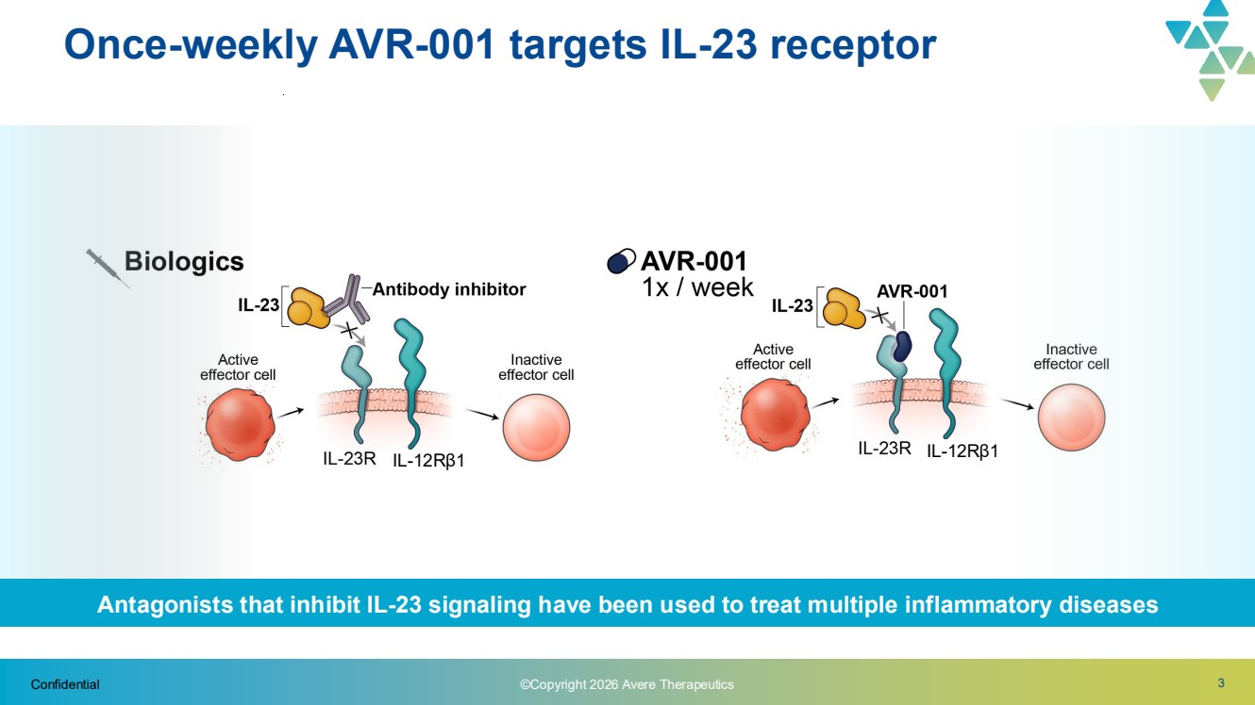 | 3 Once-weekly AVR-001 targets IL-23 receptor Confidential IL-12R1 IL-12Rβ1 IL--12Rβ1 ©Copyright 2026 Avere Therapeutics Antagonists that inhibit IL-23 signaling have been used to treat multiple inflammatory diseases
 | 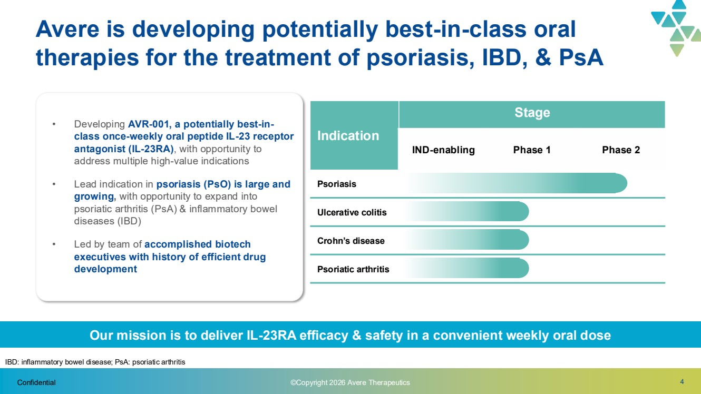 | 4 • Developing AVR-001, a potentially best-in-class once-weekly oral peptide IL-23 receptor antagonist (IL-23RA), with opportunity to address multiple high-value indications • Lead indication in psoriasis (PsO) is large and growing, with opportunity to expand into psoriatic arthritis (PsA) & inflammatory bowel diseases (IBD) • Led by team of accomplished biotech executives with history of efficient drug development Indication Stage IND-enabling Phase 1 Phase 2 Psoriasis Ulcerative colitis Crohn’s disease Psoriatic arthritis Our mission is to deliver IL-23RA efficacy & safety in a convenient weekly oral dose Confidential Avere is developing potentially best-in-class oral therapies for the treatment of psoriasis, IBD, & PsA​ IBD: inflammatory bowel disease; PsA: psoriatic arthritis ©Copyright 2026 Avere Therapeutics
 | 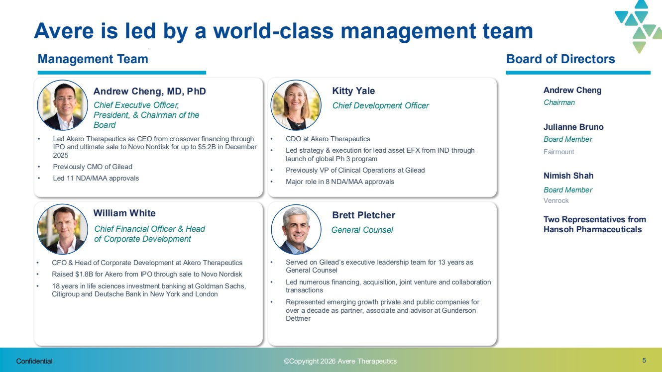 | 5 Avere is led by a world-class management team Andrew Cheng Chairman Nimish Shah Board Member Venrock Julianne Bruno Board Member Fairmount Two Representatives from Hansoh Pharmaceuticals Management Team Board of Directors Confidential ©Copyright 2026 Avere Therapeutics Andrew Cheng, MD, PhD Chief Executive Officer, President, & Chairman of the Board • Led Akero Therapeutics as CEO from crossover financing through IPO and ultimate sale to Novo Nordisk for up to $5.2B in December 2025 • Previously CMO of Gilead • Led 11 NDA/MAA approvals Kitty Yale Chief Development Officer • CDO at Akero Therapeutics • Led strategy & execution for lead asset EFX from IND through launch of global Ph 3 program • Previously VP of Clinical Operations at Gilead • Major role in 8 NDA/MAA approvals Brett Pletcher General Counsel • Served on Gilead’s executive leadership team for 13 years as General Counsel • Led numerous financing, acquisition, joint venture and collaboration transactions • Represented emerging growth private and public companies for over a decade as partner, associate and advisor at Gunderson Dettmer William White Chief Financial Officer & Head of Corporate Development • CFO & Head of Corporate Development at Akero Therapeutics • Raised $1.8B for Akero from IPO through sale to Novo Nordisk • 18 years in life sciences investment banking at Goldman Sachs, Citigroup and Deutsche Bank in New York and London
 | 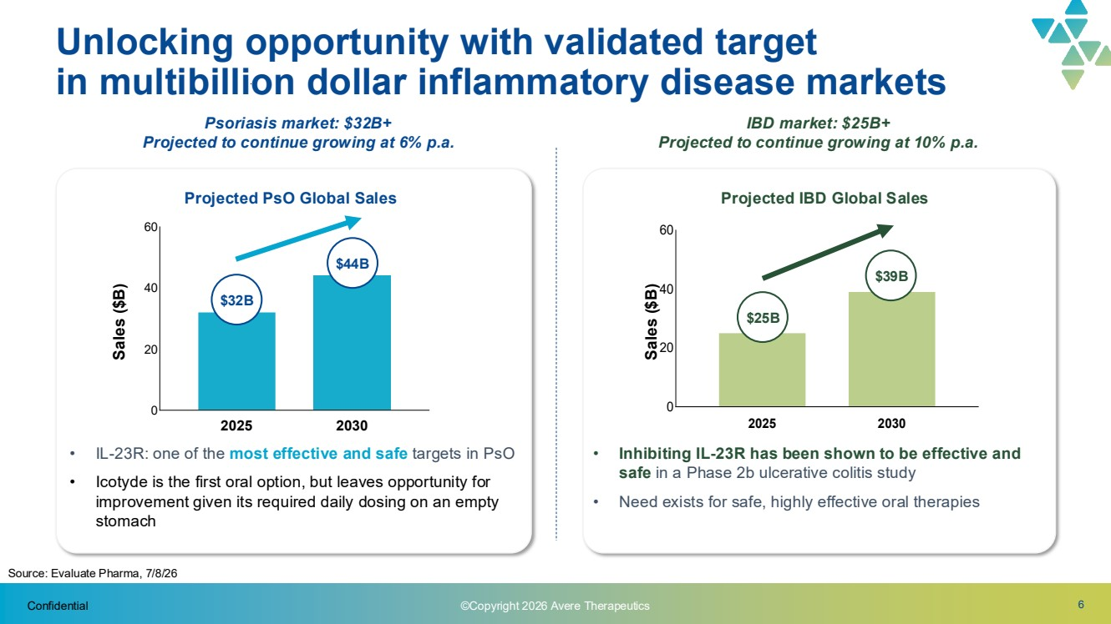 | 6 Psoriasis market: $32B+ Projected to continue growing at 6% p.a. Unlocking opportunity with validated target in multibillion dollar inflammatory disease markets • IL-23R: one of the most effective and safe targets in PsO • Icotyde is the first oral option, but leaves opportunity for improvement given its required daily dosing on an empty stomach • Inhibiting IL-23R has been shown to be effective and safe in a Phase 2b ulcerative colitis study • Need exists for safe, highly effective oral therapies IBD market: $25B+ Projected to continue growing at 10% p.a. Source: Evaluate Pharma, 7/8/26 Projected PsO Global Sales Projected IBD Global Sales Sales ($B) 2025 2030 0 20 40 60 2025 2030 0 20 40 60 Sales ($B) $32B $44B $25B $39B Confidential ©Copyright 2026 Avere Therapeutics
 | 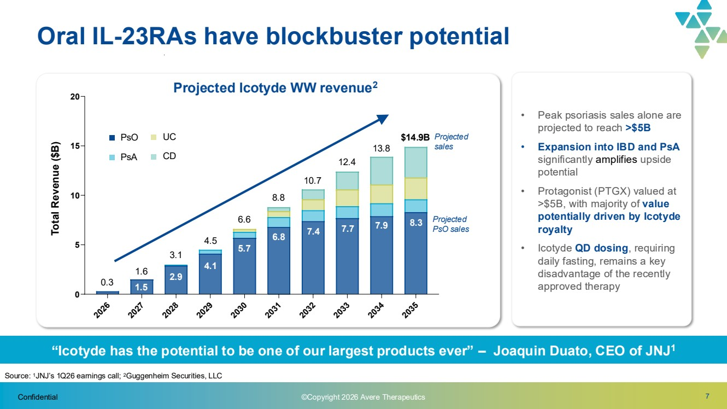 | 7 “Icotyde has the potential to be one of our largest products ever” – Joaquin Duato, CEO of JNJ1 2026 2027 2028 2029 2030 2031 2032 203 2034 2035 0 5 10 15 20 Oral IL-23RAs have blockbuster potential Projected Icotyde WW revenue2 Total Revenue ($B) Projected sales PsO PsA UC CD • Peak psoriasis sales alone are projected to reach >$5B • Expansion into IBD and PsA significantly amplifies upside potential • Protagonist (PTGX) valued at >$5B, with majority of value potentially driven by Icotyde royalty • Icotyde QD dosing, requiring daily fasting, remains a key disadvantage of the recently approved therapy Confidential Projected PsO sales Source: 1JNJ’s 1Q26 earnings call; 2Guggenheim Securities, LLC 3.1 0.3 1.6 13.8 4.5 6.6 8.8 10.7 12.4 $14.9B 4.1 5.7 6.8 7.4 7.7 7.9 8.3 2.9 1.5 ©Copyright 2026 Avere Therapeutics
 | 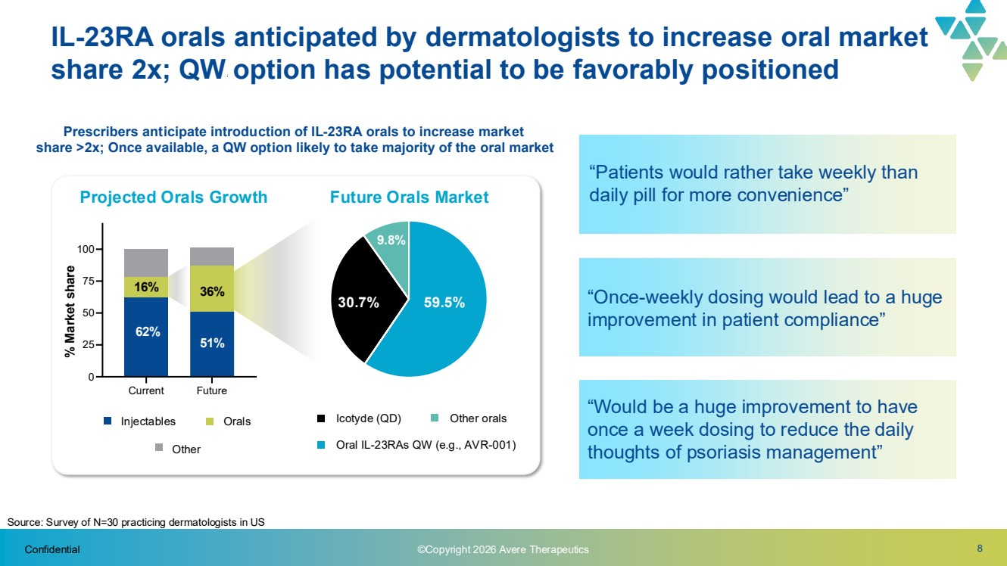 | 8 Current Future 0 25 50 75 100 “Patients would rather take weekly than daily pill for more convenience” “Once-weekly dosing would lead to a huge improvement in patient compliance” “Would be a huge improvement to have once a week dosing to reduce the daily thoughts of psoriasis management” Confidential Source: Survey of N=30 practicing dermatologists in US Prescribers anticipate introduction of IL-23RA orals to increase market share >2x; Once available, a QW option likely to take majority of the oral market 9.8% 30.7% 59.5% Projected Orals Growth Future Orals Market Injectables Orals Other Oral IL-23RAs QW (e.g., AVR-001) Icotyde (QD) Other orals 16% 36% 62% 51% % Market share IL-23RA orals anticipated by dermatologists to increase oral market share 2x; QW option has potential to be favorably positioned ©Copyright 2026 Avere Therapeutics
 | 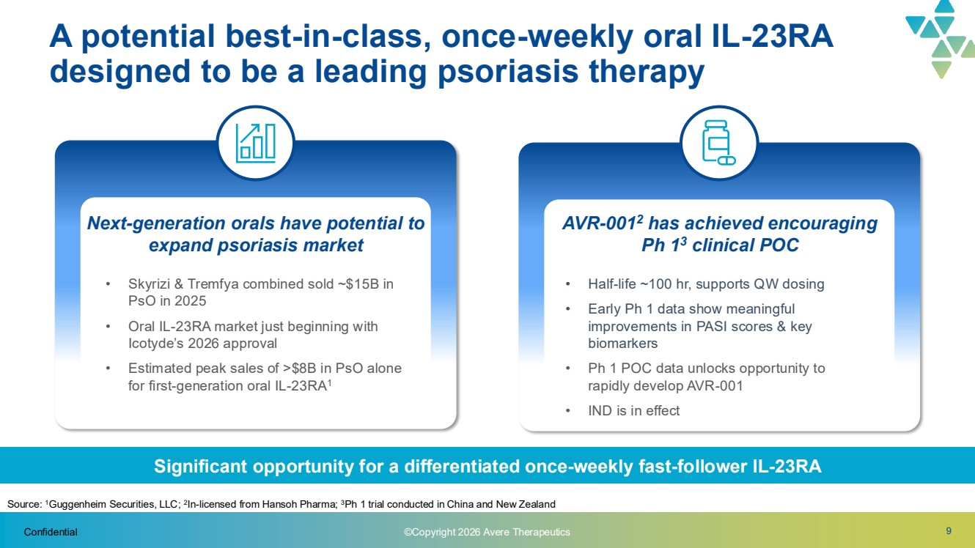 | 9 A potential best-in-class, once-weekly oral IL-23RA designed to be a leading psoriasis therapy Significant opportunity for a differentiated once-weekly fast-follower IL-23RA Next-generation orals have potential to expand psoriasis market • Skyrizi & Tremfya combined sold ~$15B in PsO in 2025 • Oral IL-23RA market just beginning with Icotyde’s 2026 approval • Estimated peak sales of >$8B in PsO alone for first-generation oral IL-23RA1 AVR-0012 has achieved encouraging Ph 13 clinical POC • Half-life ~100 hr, supports QW dosing • Early Ph 1 data show meaningful improvements in PASI scores & key biomarkers • Ph 1 POC data unlocks opportunity to rapidly develop AVR-001 • IND is in effect Confidential Source: 1Guggenheim Securities, LLC; 2 In-licensed from Hansoh Pharma; 3Ph 1 trial conducted in China and New Zealand ©Copyright 2026 Avere Therapeutics
 | 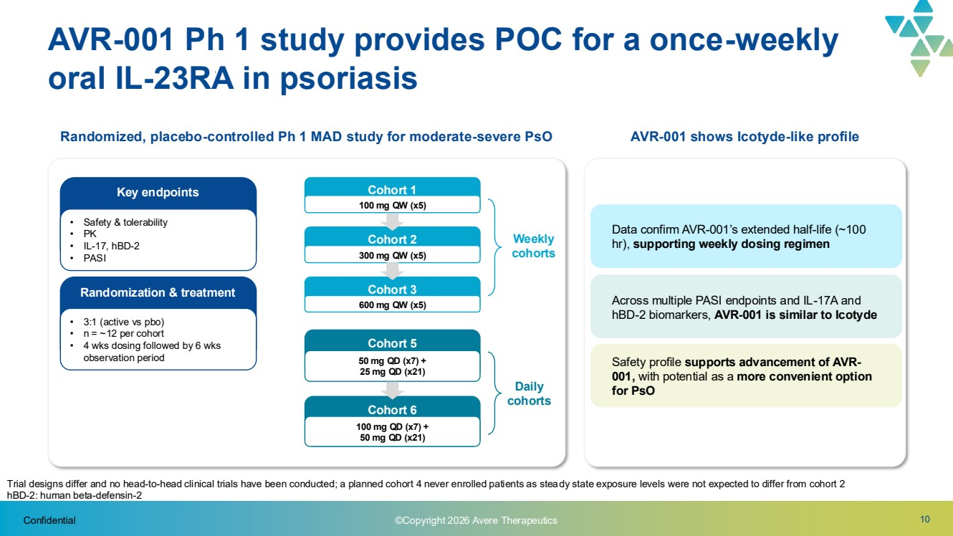 | 10 Randomized, placebo-controlled Ph 1 MAD study for moderate-severe PsO Confidential AVR-001 Ph 1 study provides POC for a once-weekly oral IL-23RA in psoriasis Cohort 3 600 mg QW (x5) Cohort 2 300 mg QW (x5) Cohort 1 100 mg QW (x5) Weekly cohorts Cohort 6 100 mg QD (x7) + 50 mg QD (x21) Cohort 5 50 mg QD (x7) + 25 mg QD (x21) Daily cohorts AVR-001 shows Icotyde-like profile Data confirm AVR-001’s extended half-life (~100 hr), supporting weekly dosing regimen Across multiple PASI endpoints and IL-17A and hBD-2 biomarkers, AVR-001 is similar to Icotyde Safety profile supports advancement of AVR-001, with potential as a more convenient option for PsO Trial designs differ and no head-to-head clinical trials have been conducted; a planned cohort 4 never enrolled patients as steady state exposure levels were not expected to differ from cohort 2 hBD-2: human beta-defensin-2 Key endpoints • Safety & tolerability • PK • IL-17, hBD-2 • PASI Randomization & treatment • 3:1 (active vs pbo) • n = ~12 per cohort • 4 wks dosing followed by 6 wks observation period ©Copyright 2026 Avere Therapeutics
 | 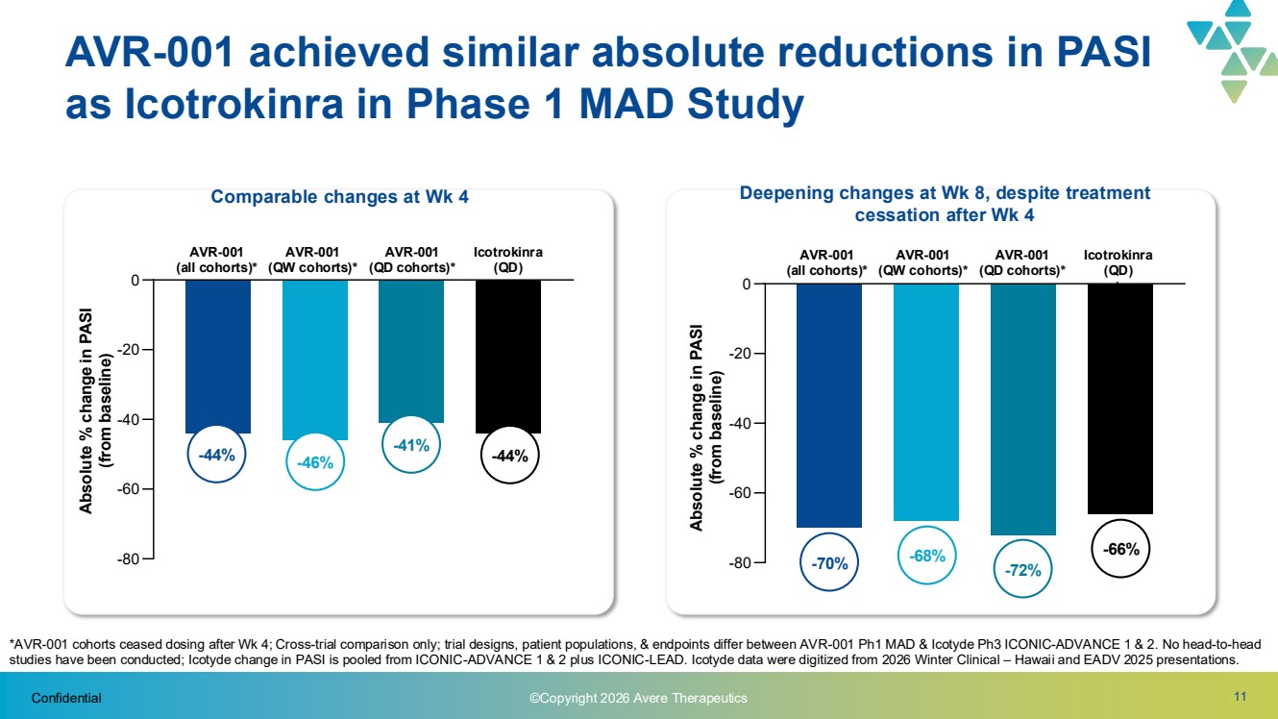 | Confidential 11 AVR-001 achieved similar absolute reductions in PASI as Icotrokinra in Phase 1 MAD Study Comparable changes at Wk 4 -80 -60 -40 -20 0 AVR-001 (all cohorts)* AVR-001 (QW cohorts)* AVR-001 (QD cohorts)* Icotrokinra (QD) Absolute % change in PASI (from baseline) -44% -46% -41% -44% -80 -60 -40 -20 0 AVR-001 (all cohorts)* AVR-001 (QW cohorts)* AVR-001 (QD cohorts)* Icotrokinra (QD) ) Deepening changes at Wk 8, despite treatment cessation after Wk 4 -70% -68% -72% -66% Absolute % change in PASI (from baseline) *AVR-001 cohorts ceased dosing after Wk 4; Cross-trial comparison only; trial designs, patient populations, & endpoints differ between AVR-001 Ph1 MAD & Icotyde Ph3 ICONIC-ADVANCE 1 & 2. No head-to-head studies have been conducted; Icotyde change in PASI is pooled from ICONIC-ADVANCE 1 & 2 plus ICONIC-LEAD. Icotyde data were digitized from 2026 Winter Clinical – Hawaii and EADV 2025 presentations. ©Copyright 2026 Avere Therapeutics
 | 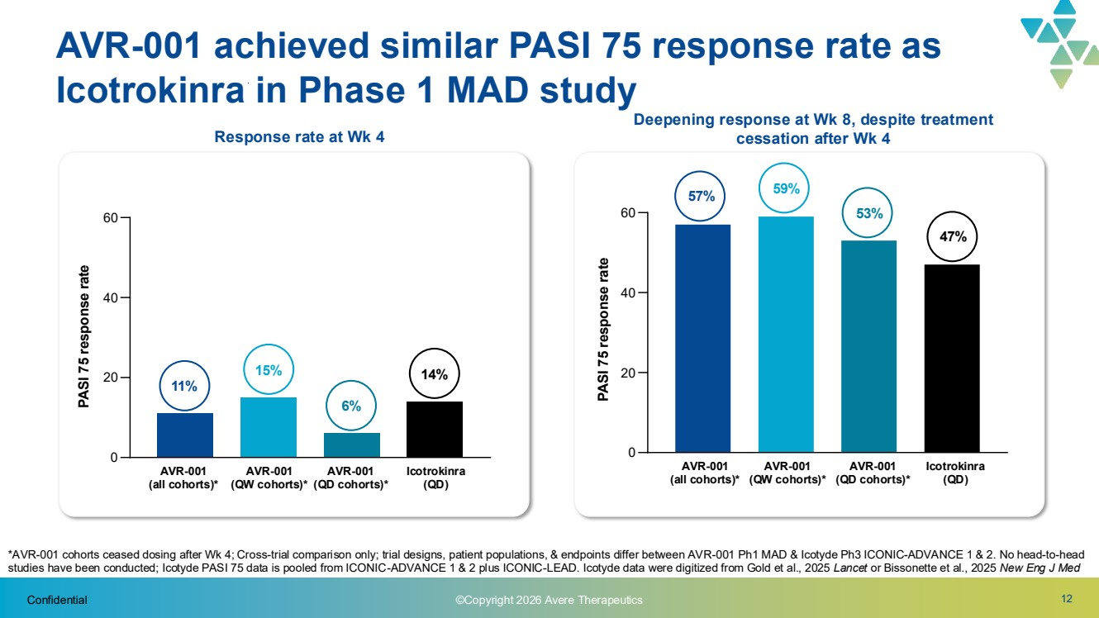 | Confidential 12 AVR-001 achieved similar PASI 75 response rate as Icotrokinra in Phase 1 MAD study Response rate at Wk 4 0 20 40 60 AVR-001 (all cohorts)* AVR-001 (QW cohorts)* AVR-001 (QD cohorts)* Icotrokinra (QD) PASI 75 response rate 11% 15% 6% 14% 0 20 40 60 AVR-001 (all cohorts)* AVR-001 (QW cohorts)* AVR-001 (QD cohorts)* Icotrokinra (QD) Deepening response at Wk 8, despite treatment cessation after Wk 4 57% 59% 53% 47% *AVR-001 cohorts ceased dosing after Wk 4; Cross-trial comparison only; trial designs, patient populations, & endpoints differ between AVR-001 Ph1 MAD & Icotyde Ph3 ICONIC-ADVANCE 1 & 2. No head-to-head studies have been conducted; Icotyde PASI 75 data is pooled from ICONIC-ADVANCE 1 & 2 plus ICONIC-LEAD. Icotyde data were digitized from Gold et al., 2025 Lancet or Bissonette et al., 2025 New Eng J Med PASI 75 response rate ©Copyright 2026 Avere Therapeutics
 | 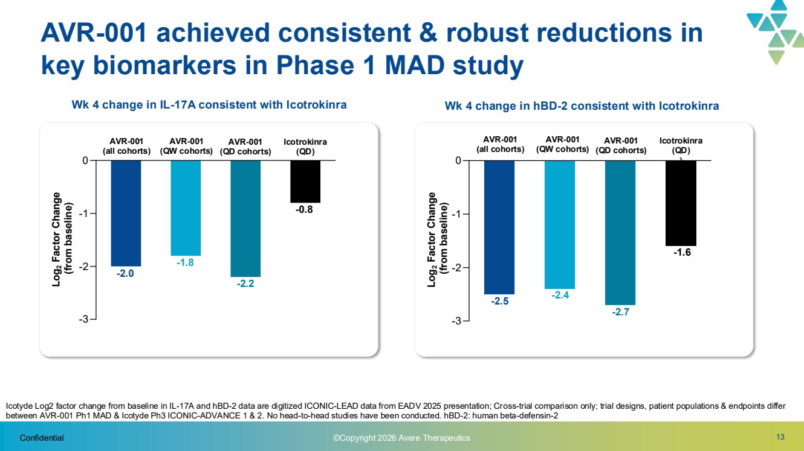 | 13 Icotyde Log2 factor change from baseline in IL-17A and hBD-2 data are digitized ICONIC-LEAD data from EADV 2025 presentation; Cross-trial comparison only; trial designs, patient populations & endpoints differ between AVR-001 Ph1 MAD & Icotyde Ph3 ICONIC-ADVANCE 1 & 2. No head-to-head studies have been conducted. hBD-2: human beta-defensin-2 Confidential AVR-001 achieved consistent & robust reductions in key biomarkers in Phase 1 MAD study -3 -2 -1 0 -3 -2 -1 0 Wk 4 change in IL-17A consistent with Icotrokinra AVR-001 (QW cohorts) Icotrokinra (QD) -1.8 -0.8 Wk 4 change in hBD-2 consistent with Icotrokinra -2.4 -1.6 -2.0 -2.2 AVR-001 (all cohorts) AVR-001 (QD cohorts) -2.7 -2.4 -2.5 AVR-001 (QW cohorts) Icotrokinra (QD) ) AVR-001 (all cohorts) AVR-001 (QD cohorts) Log2 Factor Change (from baseline) Log2 Factor Change (from baseline) ©Copyright 2026 Avere Therapeutics
 | 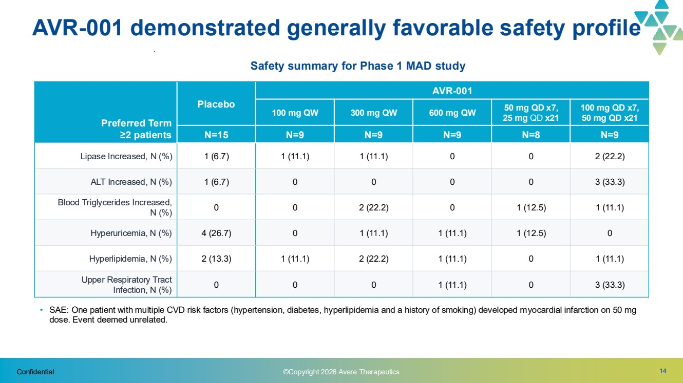 | Confidential 14 AVR-001 demonstrated generally favorable safety profile Preferred Term ≥2 patients Placebo AVR-001 100 mg QW 300 mg QW 600 mg QW 50 mg QD x7, 25 mg QD x21 100 mg QD x7, 50 mg QD x21 N=15 N=9 N=9 N=9 N=8 N=9 Lipase Increased, N (%) 1 (6.7) 1 (11.1) 1 (11.1) 0 0 2 (22.2) ALT Increased, N (%) 1 (6.7) 0 0 0 0 3 (33.3) Blood Triglycerides Increased, N (%) 0 0 2 (22.2) 0 1 (12.5) 1 (11.1) Hyperuricemia, N (%) 4 (26.7) 0 1 (11.1) 1 (11.1) 1 (12.5) 0 Hyperlipidemia, N (%) 2 (13.3) 1 (11.1) 2 (22.2) 1 (11.1) 0 1 (11.1) Upper Respiratory Tract Infection, N (%) 0 0 0 1 (11.1) 0 3 (33.3) • SAE: One patient with multiple CVD risk factors (hypertension, diabetes, hyperlipidemia and a history of smoking) developed myocardial infarction on 50 mg dose. Event deemed unrelated. ©Copyright 2026 Avere Therapeutics Safety summary for Phase 1 MAD study
 | 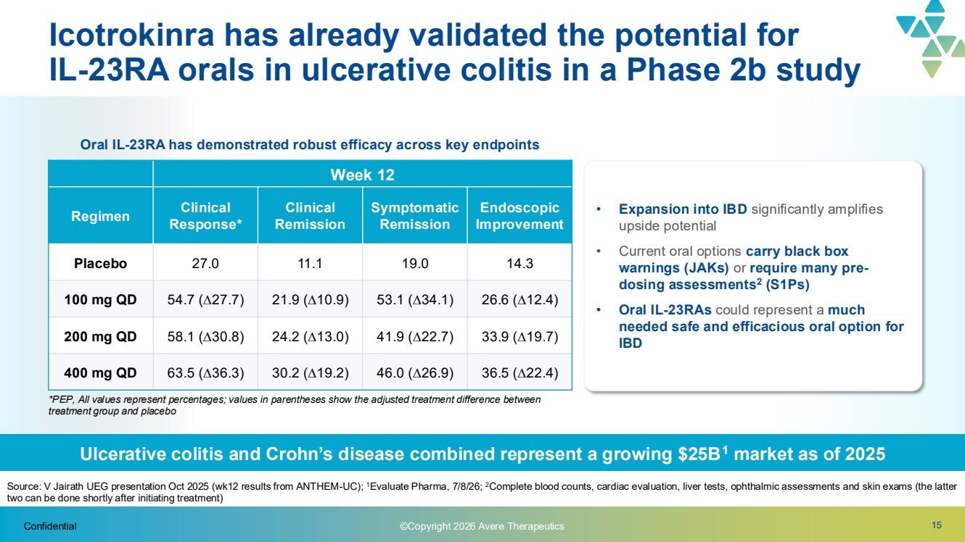 | 15 Icotrokinra has already validated the potential for IL-23RA orals in ulcerative colitis in a Phase 2b study *PEP, All values represent percentages; values in parentheses show the adjusted treatment difference between treatment group and placebo Confidential Source: V Jairath UEG presentation Oct 2025 (wk12 results from ANTHEM-UC); 1Evaluate Pharma, 7/8/26; 2Complete blood counts, cardiac evaluation, liver tests, ophthalmic assessments and skin exams (the latter two can be done shortly after initiating treatment) Week 12 Regimen Clinical Response* Clinical Remission Symptomatic Remission Endoscopic Improvement Placebo 27.0 11.1 19.0 14.3 100 mg QD 54.7 (27.7) 21.9 (10.9) 53.1 (34.1) 26.6 (12.4) 200 mg QD 58.1 (30.8) 24.2 (13.0) 41.9 (22.7) 33.9 (19.7) 400 mg QD 63.5 (36.3) 30.2 (19.2) 46.0 (26.9) 36.5 (22.4) Ulcerative colitis and Crohn’s disease combined represent a growing $25B1 market as of 2025 • Expansion into IBD significantly amplifies upside potential • Current oral options carry black box warnings (JAKs) or require many pre-dosing assessments2 (S1Ps) • Oral IL-23RAs could represent a much needed safe and efficacious oral option for IBD Oral IL-23RA has demonstrated robust efficacy across key endpoints ©Copyright 2026 Avere Therapeutics
 | 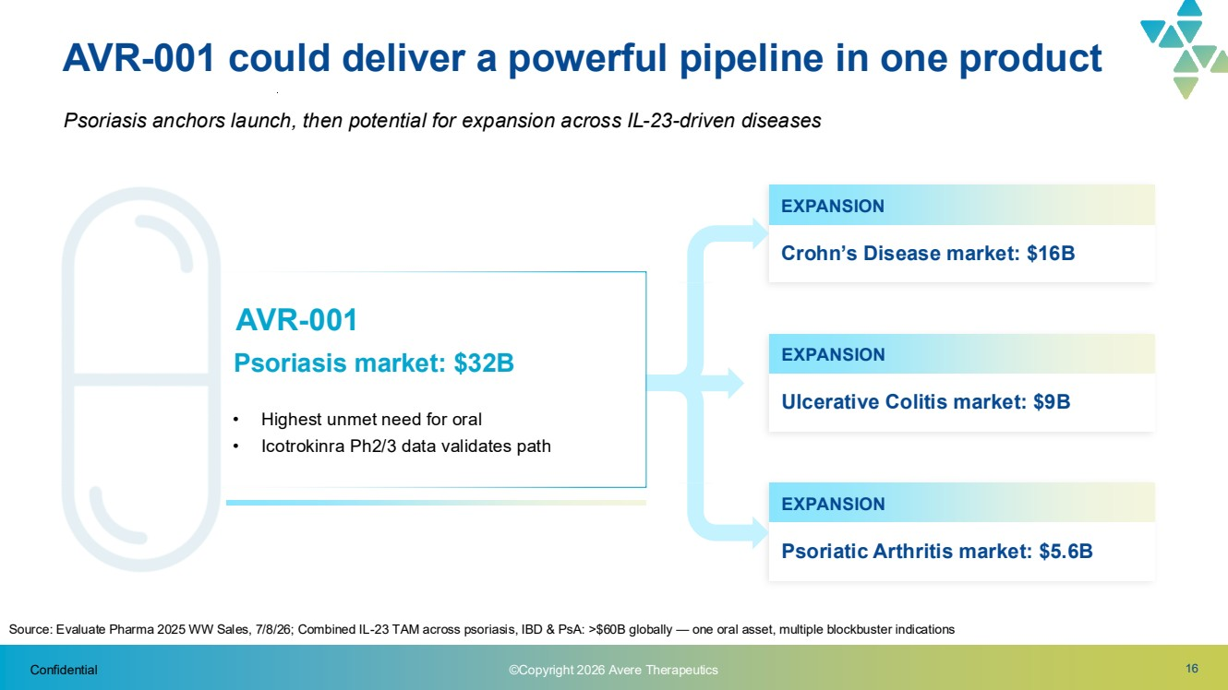 | 16 AVR-001 could deliver a powerful pipeline in one product​ Psoriasis anchors launch, then potential for expansion across IL-23-driven diseases AVR-001 Psoriasis market: $32B • Highest unmet need for oral • Icotrokinra Ph2/3 data validates path Source: Evaluate Pharma 2025 WW Sales, 7/8/26; Combined IL-23 TAM across psoriasis, IBD & PsA: >$60B globally — one oral asset, multiple blockbuster indications EXPANSION Ulcerative Colitis market: $9B EXPANSION Crohn’s Disease market: $16B EXPANSION Psoriatic Arthritis market: $5.6B Confidential ©Copyright 2026 Avere Therapeutics
 | 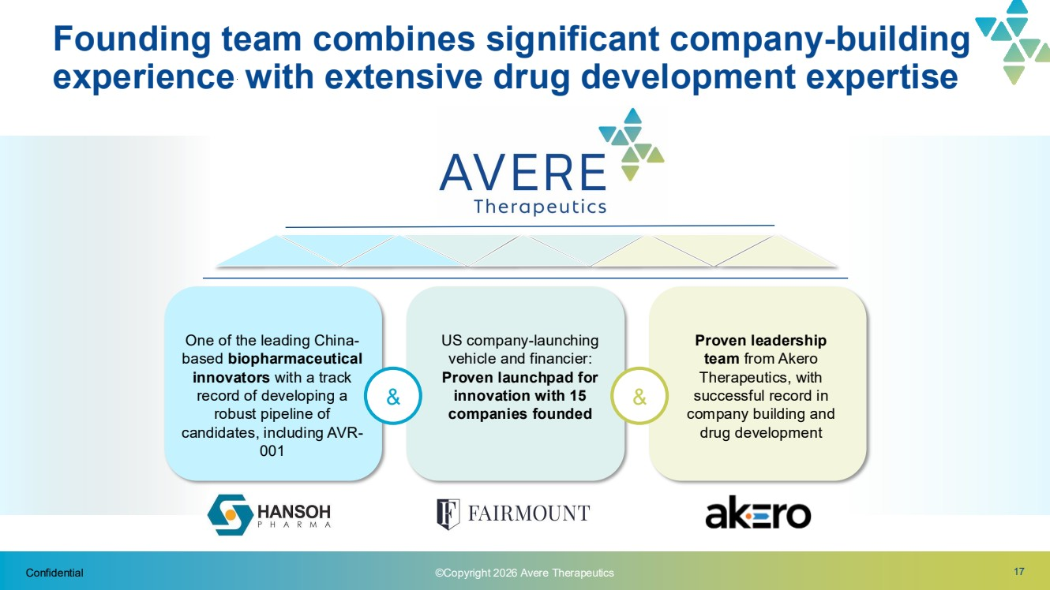 | 17 Founding team combines significant company-building experience with extensive drug development expertise & & One of the leading China-based biopharmaceutical innovators with a track record of developing a robust pipeline of candidates, including AVR-001 US company-launching vehicle and financier: Proven launchpad for innovation with 15 companies founded Proven leadership team from Akero Therapeutics, with successful record in company building and drug development Confidential ©Copyright 2026 Avere Therapeutics
 | 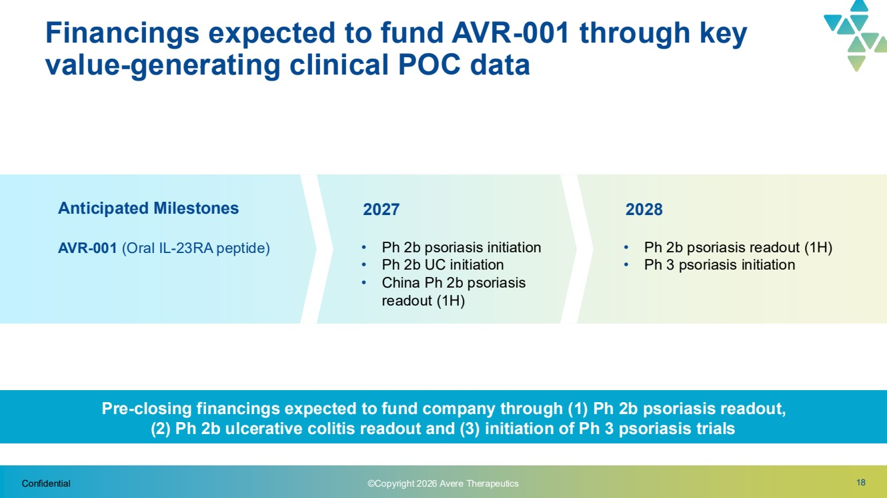 | 18 Financings expected to fund AVR-001 through key value-generating clinical POC data​ • Ph 2b psoriasis initiation • Ph 2b UC initiation • China Ph 2b psoriasis readout (1H) 2027 2028 AVR-001 (Oral IL-23RA peptide) • Ph 2b psoriasis readout (1H) • Ph 3 psoriasis initiation Anticipated Milestones Confidential ©Copyright 2026 Avere Therapeutics Pre-closing financings expected to fund company through (1) Ph 2b psoriasis readout, (2) Ph 2b ulcerative colitis readout and (3) initiation of Ph 3 psoriasis trials
 | 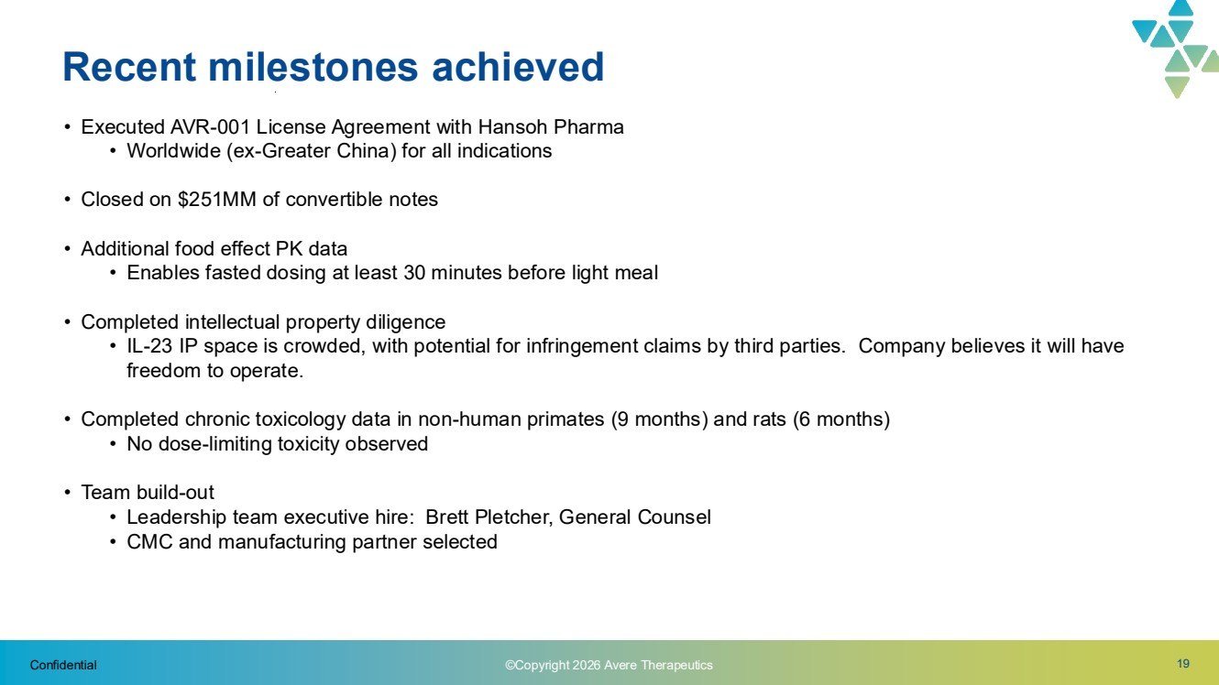 | 19 Recent milestones achieved Confidential ©Copyright 2026 Avere Therapeutics • Executed AVR-001 License Agreement with Hansoh Pharma • Worldwide (ex-Greater China) for all indications • Closed on $251MM of convertible notes • Additional food effect PK data • Enables fasted dosing at least 30 minutes before light meal • Completed intellectual property diligence • IL-23 IP space is crowded, with potential for infringement claims by third parties. Company believes it will have freedom to operate. • Completed chronic toxicology data in non-human primates (9 months) and rats (6 months) • No dose-limiting toxicity observed • Team build-out • Leadership team executive hire: Brett Pletcher, General Counsel • CMC and manufacturing partner selected
 | 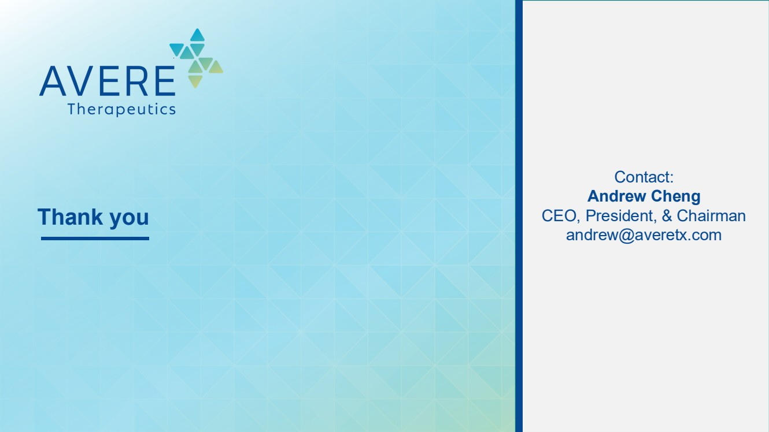 | Thank you Contact: Andrew Cheng CEO, President, & Chairman andrew@averetx.com

Forward-Looking Statements

This communication contains forward-looking statements (including within the meaning of Section 21E of the Exchange Act and Section 27A of the Securities Act) concerning NextCure, Avere, the proposed transactions and other matters. These forward-looking statements include express or implied statements relating to the structure, timing and completion of the proposed Merger; the combined company's listing on Nasdaq after closing of the proposed Merger; expectations regarding the ownership structure of the combined company; expectations regarding the financing transaction and the closing thereof; the expected executive officers and directors of the combined company; the future operations of the combined company; the nature, strategy and focus of the combined company; the development and commercial potential and potential benefits of any product candidates of Avere or the combined company; anticipated preclinical and clinical drug development activities and related timelines, including the expected timing for data and other clinical results; the expected cash runway and capital resources of the combined company; statements contained in the presentation regarding Avere's platform, pipeline and product candidates; and any statements contained herein that are not statements of historical fact may be deemed to be forward-looking statements. In some cases, you can identify forward-looking statements by terminology such as “aim”, “anticipate”, “assume”, “believe”, “continue”, “could”, “should”, “due”, “estimate”, “expect”, “intend”, “hope”, “may”, “objective”, “plan”, “predict”, “potential”, “positioned”, “seek”, “target”, “towards”, “forward”, “later”, “will”, “would”, and other similar expressions that are predictions of or indicate future events and future trends, or the negative of these terms or similar language. These forward-looking statements are based on current expectations and beliefs concerning future developments and their potential effects. There can be no assurance that future developments affecting NextCure, Avere or the proposed transaction will be those that have been anticipated.

Forward-looking statements involve substantial risks and uncertainties that could cause actual results to differ materially from those projected in any forward-looking statement. These risks and uncertainties include, but are not limited to, risks associated with the possible failure to satisfy the conditions to the closing or consummation of the Merger, including NextCure's failure to obtain stockholder approval for the Merger, risks associated with the potential failure to complete the financing transaction in a timely manner or at all, risks associated with the uncertainty as to the timing of the consummation of the Merger and the ability of each of NextCure and Avere to consummate the transactions contemplated by the Merger, risks associated with NextCure's continued listing on Nasdaq until closing of the Merger, the failure or delay in obtaining required approvals from any governmental or quasi-governmental entity necessary to consummate the Merger; the occurrence of any event, change or other circumstance or condition that could give rise to the termination of the Merger prior to the closing or consummation of the Merger, risks associated with the possible failure to realize certain anticipated benefits of the Merger, including with respect to future financial and operating results; the effect of the completion of the Merger on the combined company's business relationships, operating results and business generally; risks associated with the combined company's ability to manage expenses and unanticipated spending and costs that could reduce the combined company's cash resources; risks related to the combined company's ability to correctly estimate its operating expenses and other events; changes in capital resource requirements; risks related to the inability of the combined company to obtain sufficient additional capital to continue to advance its product candidates or its preclinical programs; the outcome of any legal proceedings that may be instituted against the combined company or any of its directors or officers related to the Merger Agreement or the transactions contemplated thereby; the ability of the combined company to obtain, maintain and protect its intellectual property rights, in particular those related to its product candidates; the combined company's ability to advance the development of its product candidates or preclinical activities under the timelines it anticipates in planned and future clinical trials; the combined company's ability to replicate in later clinical trials positive results found in preclinical studies and early-stage clinical trials of its product candidates; the combined company's ability to realize the anticipated benefits of its research and development programs, strategic partnerships, licensing programs or other collaborations; regulatory requirements or developments and the combined company's ability to obtain necessary approvals from the U.S. Food and Drug Administration or other regulatory authorities; changes to clinical trial designs and regulatory pathways; competitive responses to the Merger and changes in expected or existing competition; unexpected costs, charges or expenses resulting from the Merger; potential adverse reactions or changes to business relationships resulting from the completion of the Merger; legislative, regulatory, political and economic developments; changes in international relations, tariffs, and other trade regulations between the U.S. and China; and the impact of current and future laws and regulations. More detailed information on these and additional factors that could affect NextCure's actual results is described under the heading “Risk Factors” in NextCure's most recent Annual Report on Form 10-K, Quarterly Report on Form 10-Q and in NextCure's other filings with the Securities and Exchange Commission. You should not place undue reliance on any forward-looking statements. Forward-looking statements speak only as of the date of this communication, and NextCure assumes no obligation to update any forward-looking statements, even if expectations change.

No Offer or Solicitation

This communication is not intended to and does not constitute (i) a solicitation of a proxy, consent or approval with respect to any securities or in respect of the proposed transaction or (ii) an offer to sell or the solicitation of an offer to subscribe for or buy or an invitation to purchase or subscribe for any securities pursuant to the proposed transaction or otherwise, nor shall there be any sale, issuance or transfer of securities in any jurisdiction in contravention of applicable law. No offer of securities shall be made except by means of a prospectus meeting the requirements of the Securities Act or an exemption therefrom. Subject to certain exceptions to be approved by the relevant regulators or certain facts to be ascertained, the public offer will not be made directly or indirectly, in or into any jurisdiction where to do so would constitute a violation of the laws of such jurisdiction, or by use of the mails or by any means or instrumentality (including without limitation, facsimile transmission, telephone and the internet) of interstate or foreign commerce, or any facility of a national securities exchange, of any such jurisdiction.

NEITHER THE SEC NOR ANY STATE SECURITIES COMMISSION HAS APPROVED OR DISAPPROVED OF THE SECURITIES OR DETERMINED IF THIS COMMUNICATION ARE TRUTHFUL OR COMPLETE.

Important Additional Information About the Proposed Transaction Will be Filed with the SEC

This communication is not a substitute for any other document that NextCure may file with the SEC in connection with the proposed transaction, including the registration statement on Form S-4 (the “Form S-4”) that will contain a proxy statement and prospectus. In connection with the proposed transaction between NextCure and Avere, NextCure intends to file relevant materials with the SEC, including the Form S-4. NEXTCURE URGES INVESTORS AND STOCKHOLDERS TO READ THE REGISTRATION STATEMENT, INCLUDING THE PROXY STATEMENT/PROSPECTUS CONTAINED THEREIN, AND ANY OTHER RELEVANT DOCUMENTS THAT MAY BE FILED WITH THE SEC, AS WELL AS ANY AMENDMENTS OR SUPPLEMENTS TO THESE DOCUMENTS, CAREFULLY AND IN THEIR ENTIRETY IF AND WHEN THEY BECOME AVAILABLE BECAUSE THEY WILL CONTAIN IMPORTANT INFORMATION ABOUT NEXTCURE, AVERE, THE PROPOSED TRANSACTION AND RELATED MATTERS. Investors and stockholders will be able to obtain free copies of the Form S-4 and other documents filed by NextCure with the SEC (when they become available) through the website maintained by the SEC at www.sec.gov. In addition, investors and stockholders should note that NextCure communicates with investors and the public using its website (https://www.nextcure.com) and the investor relations website (https:ir.nextcure.com/) where anyone will be able to obtain free copies of the Registration Statement and included proxy statement/prospectus and other documents filed by NextCure with the SEC and stockholders are urged to read the Registration Statement and included proxy statement/prospectus and the other relevant materials when they become available before making any voting or investment decision with respect to the proposed transaction.

Participants in the Solicitation

NextCure, Avere and their respective directors and executive officers may be deemed to be participants in the solicitation of proxies from stockholders in connection with the proposed transaction. Information about NextCure’s directors and executive officers, including a description of their interests in NextCure, is included in NextCure’s most recent definitive proxy statement, as filed with the SEC on April 24, 2026. Additional information regarding these persons and their interests in the proposed transaction will be included in the proxy statement/prospectus relating to the proposed transaction when it is filed with the SEC. These documents can be obtained free of charge from the sources indicated above.

